- SYSTEM MODELS部分只有一个A部分Access Authentication Modes，有点奇怪。（这部分）

所有的图注都没有加

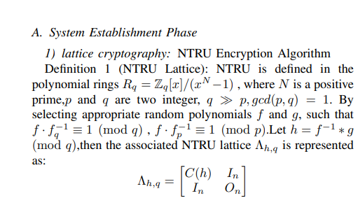
这个地方的标题会不会有点杂乱
（参考参考文献内的写法，用黑点来保证内容的可读性，实在看不懂可以和我讨论）
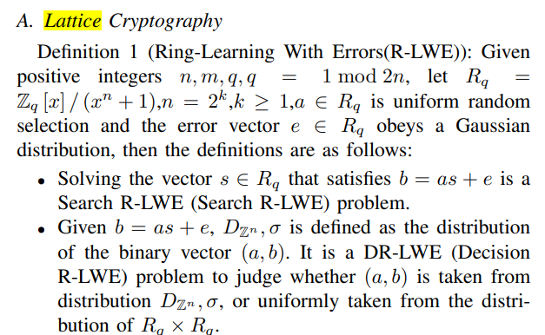

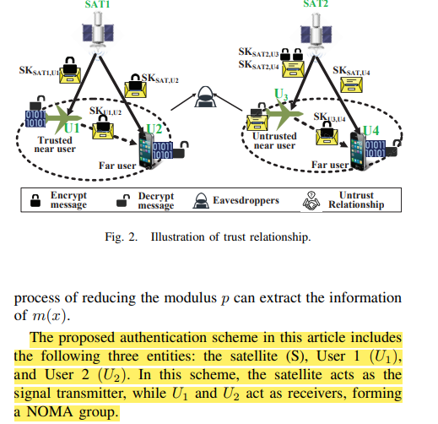
标黄部分要不要放到下面NOMA Group Characteristics:内

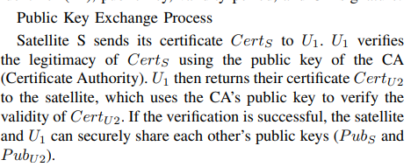
Public Key Exchange Process 没有标黑与前面一致
S变为SAT,其余部分需要大改，Taking the exchange of public keys between SAT and U1 as an example，。。。U1 then returns its certificate CertU1 to the satellite，which uses the CA’s public key to verify the validity of CertU1. 最后是PubS and PubU1。最后加一句Similar to the above process, SAT and U2, as well as U1 and U2, each perform a public key exchange.

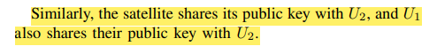
这里应该是所有节点共享其余的公钥

这什么攻击部分感觉有些突兀（这段我单独放在问题修改word里了）
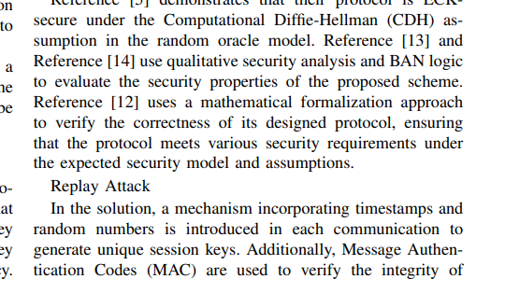
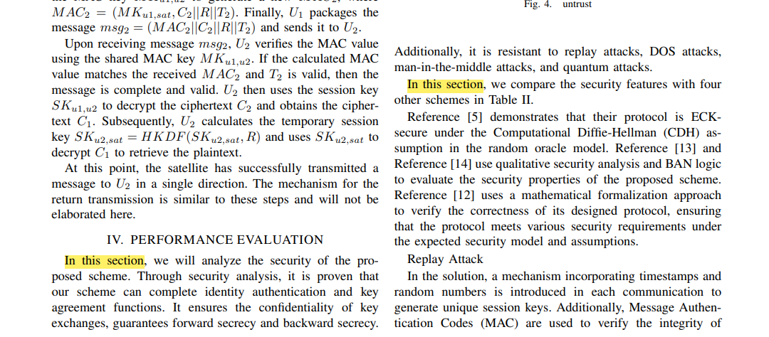
这两个In this section 有点不对

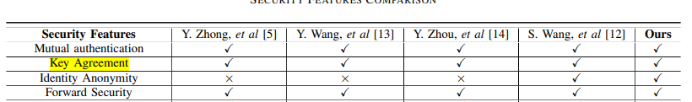
我们方案没有身份匿名

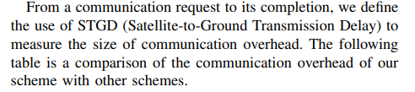
加一句and a satellite-toground transmission delay(STGD) is about 4.833ms.

可能需要讨论一下结论部分措辞。

参考文献添加部分
M. Burrows, M. Abadi, and R. M. Needham, “A logic of authentication,” ACM Trans. Comput. Syst., vol. 23, no. 5, pp. 1–13, 1989.
添加在BAN logic旁边
@article{10.1145/77648.77649,
author = {Burrows, Michael and Abadi, Martin and Needham, Roger},
title = {A logic of authentication},
year = {1990},
issue_date = {Feb. 1990},
publisher = {Association for Computing Machinery},
address = {New York, NY, USA},
volume = {8},
number = {1},
issn = {0734-2071},
url = {https://doi.org/10.1145/77648.77649},
doi = {10.1145/77648.77649},
abstract = {Authentication protocols are the basis of security in many distributed systems, and it is therefore essential to ensure that these protocols function correctly. Unfortunately, their design has been extremely error prone. Most of the protocols found in the literature contain redundancies or security flaws. A simple logic has allowed us to describe the beliefs of trustworthy parties involved in authentication protocols and the evolution of these beliefs as a consequence of communication. We have been able to explain a variety of authentication protocols formally, to discover subtleties and errors in them, and to suggest improvements. In this paper we present the logic and then give the results of our analysis of four published protocols, chosen either because of their practical importance or because they serve to illustrate our method.},
journal = {ACM Trans. Comput. Syst.},
month = feb,
pages = {18–36},
numpages = {19}
}
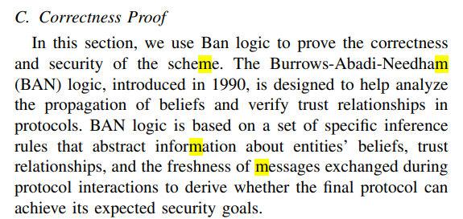

修改意见
CA部分放在system model 里面，适当加一点关于攻击者模型的内容。
图2里的所有符号均有下标。
拓展一下短期密钥和长期密钥部分，作为一个特色。
格密码部分作一下标题调整以及表达方式。
First什么的改成1）2）3）或者·或者a b c
C-NOMA Communication Feature结合图片来描述，或者把这部分放在系统模型部分，不采用U1U2等描述。
Public Key Registration and Certificate Issuance调整。
Key Negotiation Phase首先是一个总述介绍它要干什么，然后后面的步骤分步进行要清晰。
C NOMA Group And Satellite Message Relay Phase
改成安全的NOMA通信过程
Trust Mode部分也用小的序号来使更清晰
Attack部分需要雕琢一下，专业性强一点。
PERFORMANCE ANALYSIS后有一小段话，从什么方面对性能进行比较，介绍一下Communication Overhead和Computation Overhead，简述一下这部分的过程。
把通信开销那里合成一段。STDG那里把NTRU那篇当成参考文献，引用它来评价STGD这个参数。
计算开销那引用另外的文献，仿照别人的方式来进行评价。

正确性证明部分,用黑点来区分每一个定义，使文章更清晰。

长期密钥短期密钥准备放在哪，是特色。

